ODHS QUIZ

Shashwat Harsh| 220953028

# Q1

#include <stdio.h>

typedef struct employee

{

    char name[50];

    int age;

    int yoj;

    int expe;

}employee;

int calculateExperience(int year)

{

    int thisyear=2023;

    return (thisyear-year);

}

int main() {

   employee e[3];

   int max=2;

   for (int i=0;i<max;i++)

   {

        printf("enter %dth employee ",i+1);

       printf("Name: ");

        scanf("%s", e[i].name);

        printf("Age: ");

        scanf("%d", &e[i].age);

        printf("Year of Joining: ");

        scanf("%d", &e[i].yoj);

        // Calculate experience

        e[i].expe = calculateExperience(e[i].yoj);

        printf("\n");

   }

  printf("Employee Details:\n");

    for (int i = 0; i < max; i++) {

        printf("Employee %d:\n", i + 1);

        printf("Name: %s\n", e[i].name);

        printf("Age: %d\n", e[i].age);

        printf("Year of Joining: %d\n", e[i].yoj);

        printf("Experience: %d years\n", e[i].expe);

        printf("\n");

    }

    return 0;

}

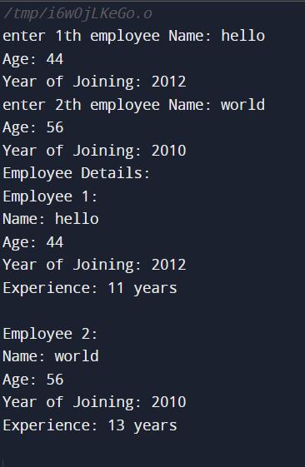

# Q2

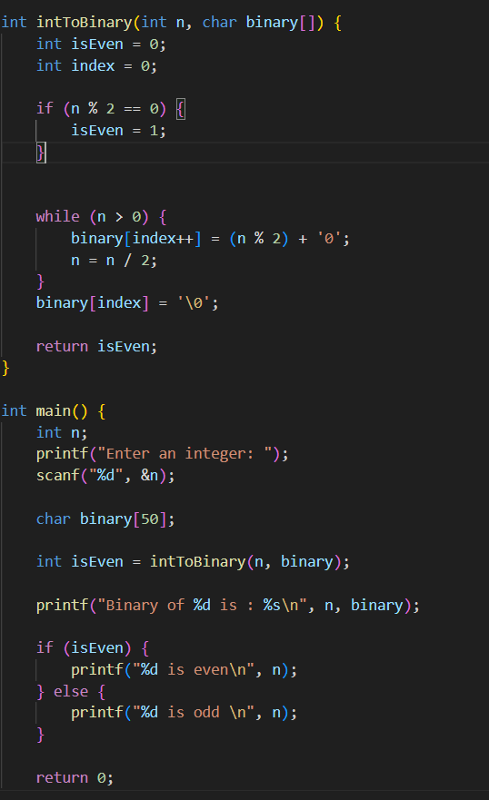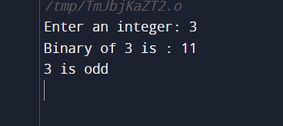

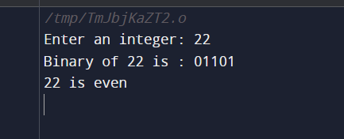

# Q3

